***BOOT FILE SYSTEM MISSING***

* ***Whenever server will be strucked in grub level***

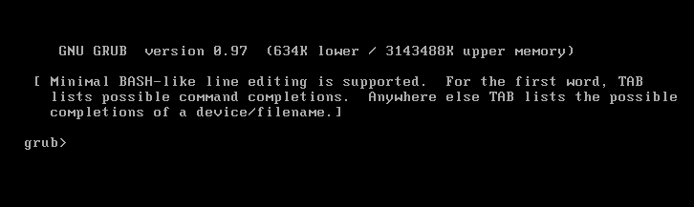

* + ***I will load kernel and initrd manually.***
  + ***First go to boot location to loading the kernel.***
  + ***Here we cannot load kernel and initrd manually file not found will get error message.***

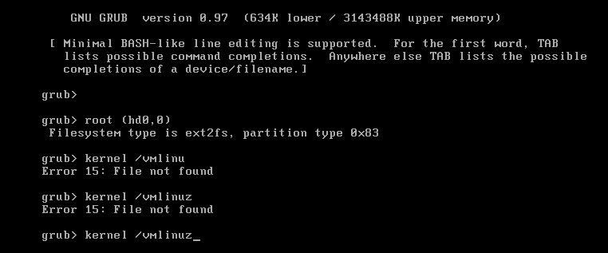

***S0 I will go to rescue mode then restart the server and press esc button and it will show CD-ROM drive.***

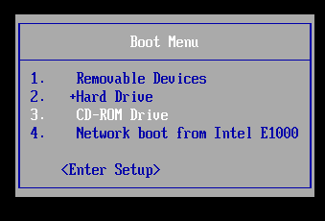

***Then it will goes to rescue mode.***

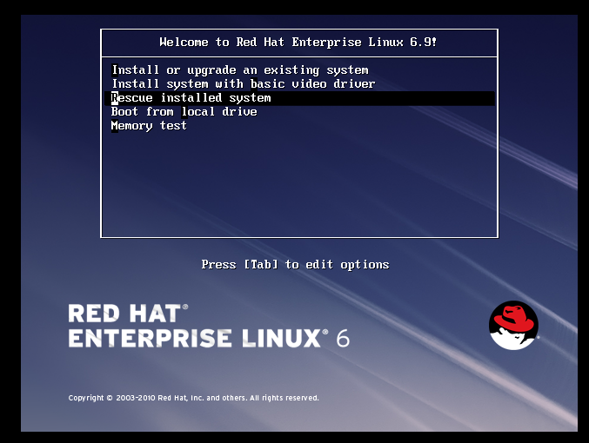

***Here select highlighted option english and us then choose ok option.***

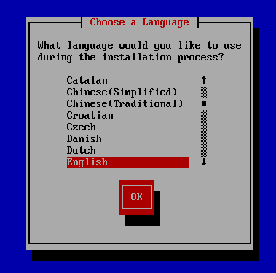

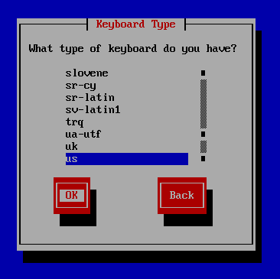

***Here if you want to server will be network choose yes otherwise no option, the press ok option.***

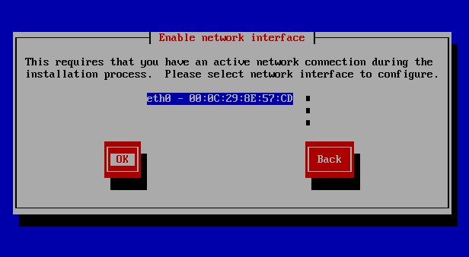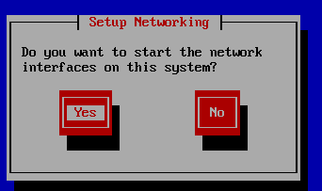

***Now here selects manual configuration to assign IPV4 address and gateway then press ok option. Then server will get into network level.***

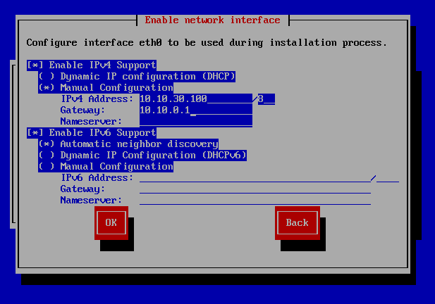

***Here our entire system will be mounted on /mnt/sysimage then select continue option.***

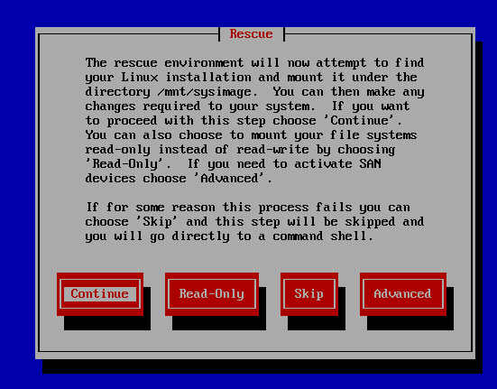

***Here says this message your system has been mounted under /mnt/sysimage/***

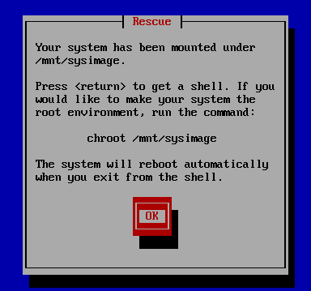

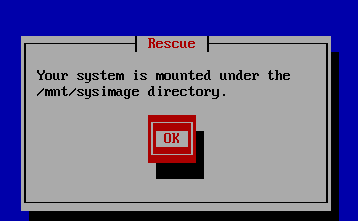

***Here chooses highlighted option shell. It will provide shell then we can hit on command.***

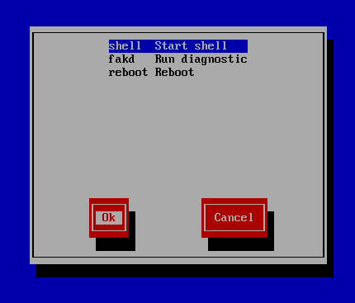

* ***After provides shell then check df –h it shows output /mnt/sysimage/.***
* ***So it not convenient then we have to change to (/).***

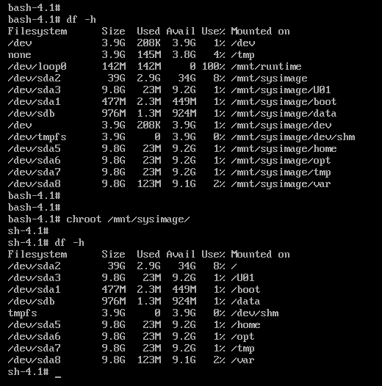

* ***Now go to boot directory location check grub configuration file available or not.***
* ***So finally there is any grub configuration file is not present.***

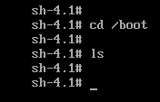

***Now here we are get back grub configuration file to five (5) ways.***

* ***Using RPM (use RPM install kernel #rpm – ivh <kernel.rpm> --force).***
* ***Using yum local repository***
* ***Using yum http server***
* ***Using yum ftp server***
* ***Using scp command from another server to corrupted server.***
* ***Now we can choose yum local repository.***
* ***Now connect to putty but cannot connect to putty, because sshd service state will be stopped.***
* ***Then start the service.***

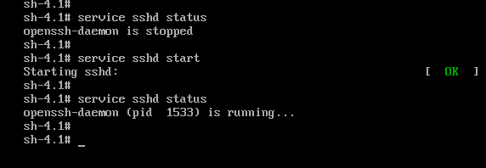

***Now create a local repo file in yum configuration file # cd /etc/yum.repos.d***

***Now temporary mounting on mnt file system.***

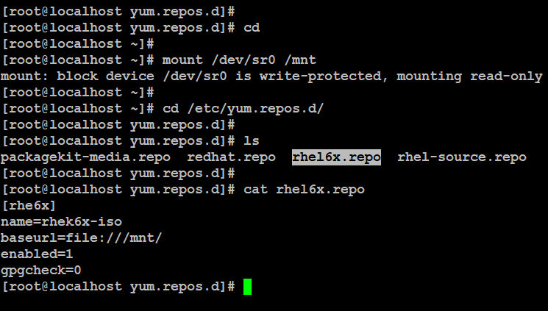

***Now we can install kernel using yum.***

***So we can re-insatll kernel through yum.***

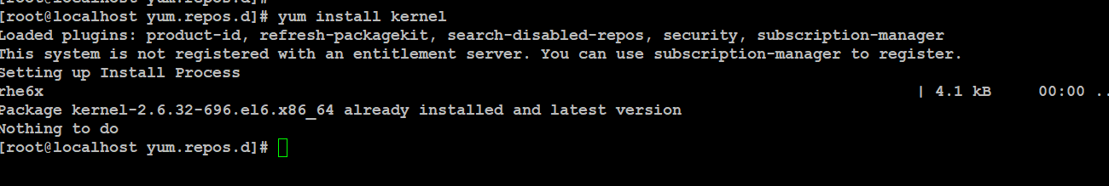

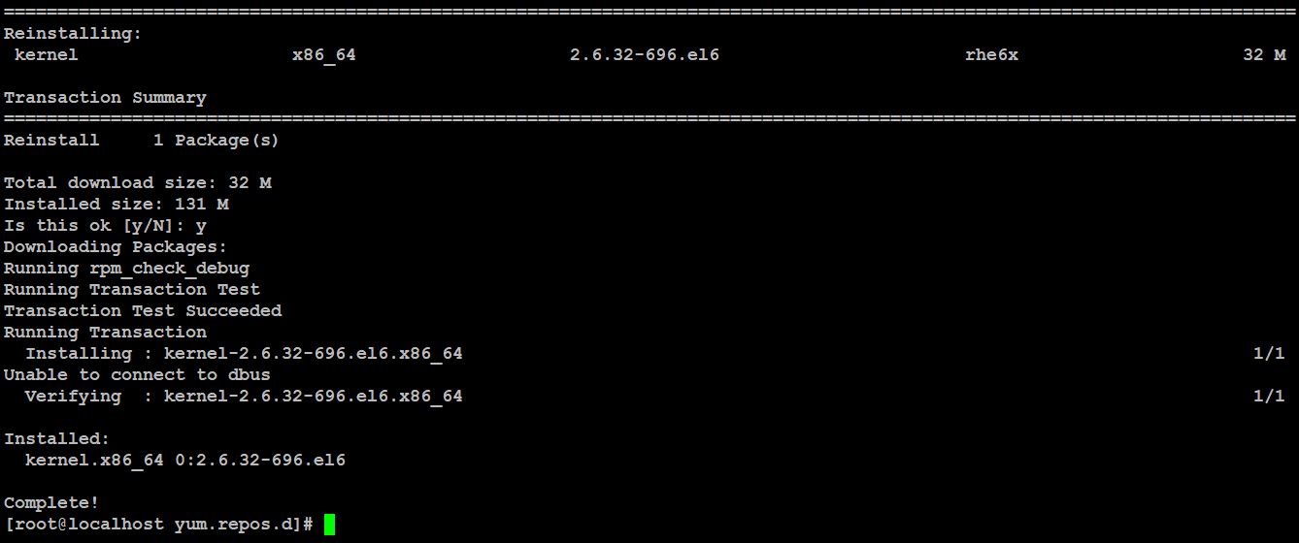

***Now go to boot location and check the installed kernels will get or not.***

***so kernel will be present but grub directory not present.***

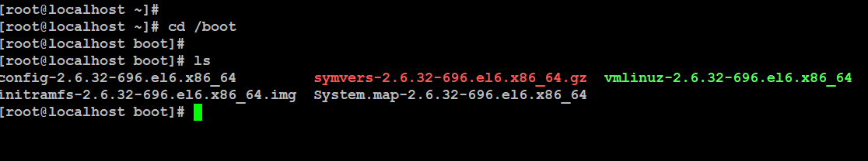

***So we can install grub directory. Then go and check /boot/grub/device.map shows information.***

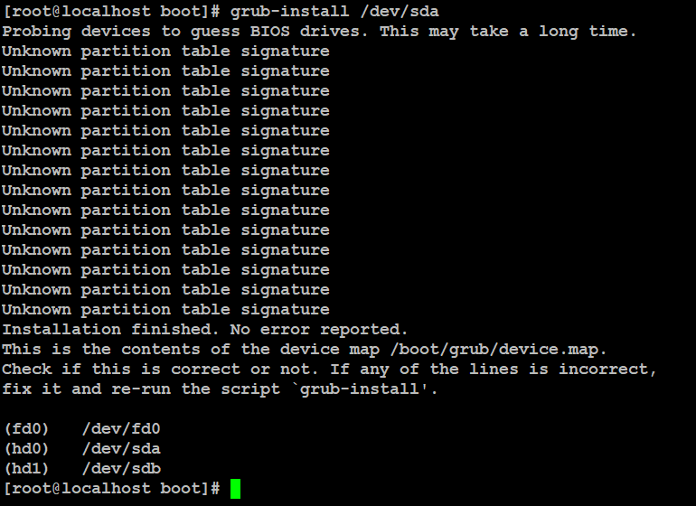

* ***Next go to boot location and check grub directory installed or not.***
* ***So grub directory not installed.***
* ***Then got grub directory check grub configuration file not available.***

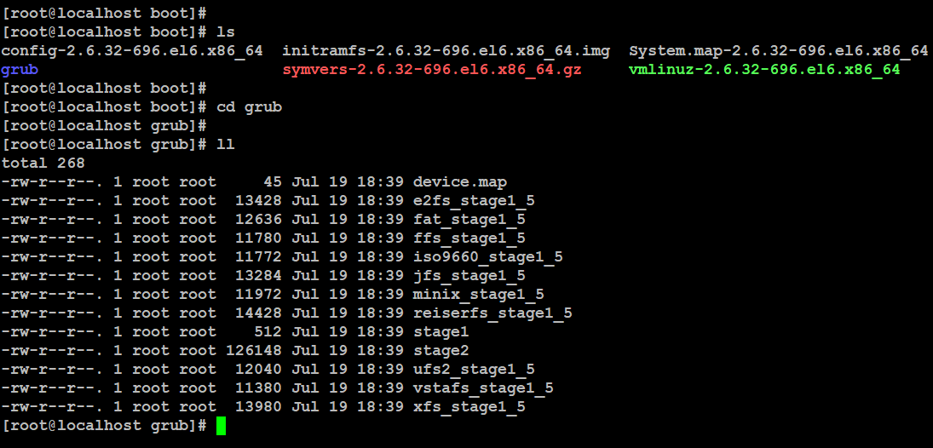

* ***Then to copy the grub configuration file from peer server that I was deployed from same template.***
* ***That means good condition server to copy from corrupted server.***
* ***So we need /boot/grub location and use scp command.***

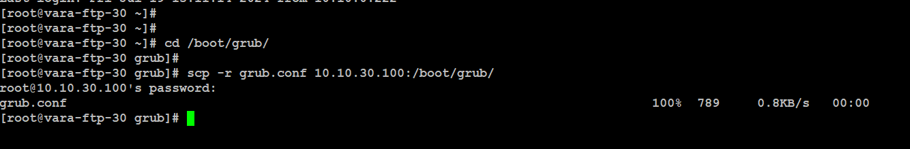

***Then boot location and grub configuration file is available.***

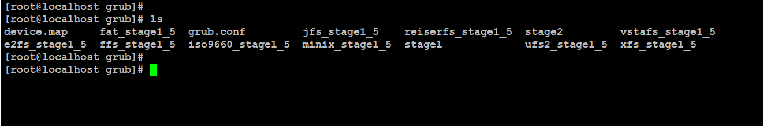

***To check grub configuration file ro root uuid= / partition uuid both are same to check if it is not same to copy from / partition uuid to grub configuration file,by using blkid or lsblk-f command.***

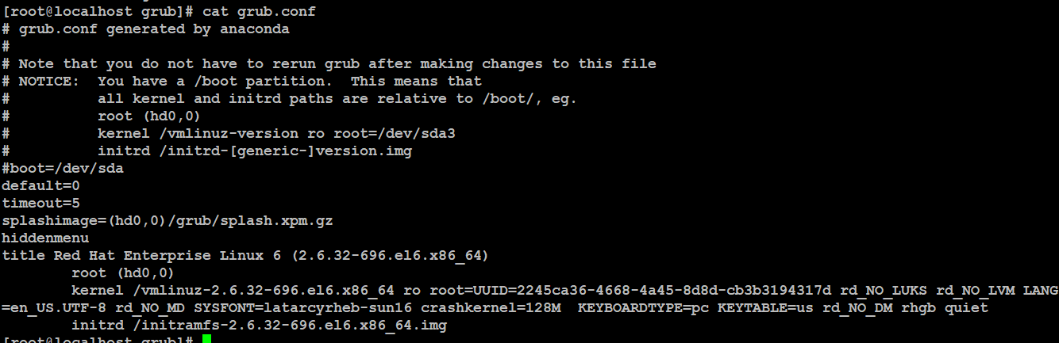

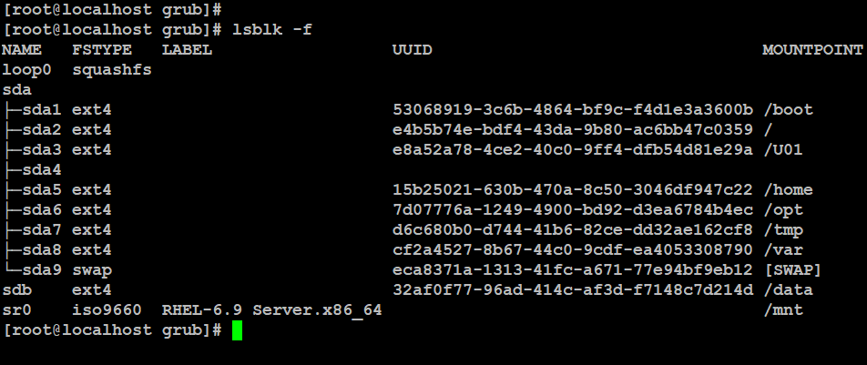

***So finally reboot the server using (#reboot –f or ctrl+d then reboot) then server will be up in good condition.***

***So login to server and check grub configuration file is available.***

